CICD Pipeline

Project1_CI

Jenkins job to to get the source code from <https://github.com/Bikash376919/code-test.git> using webhook trigger and place the war file in Ansible controller

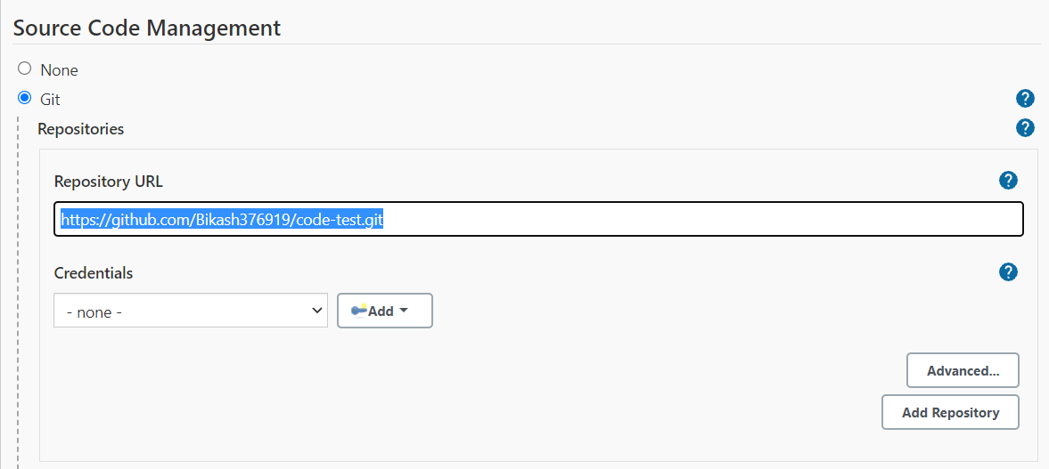

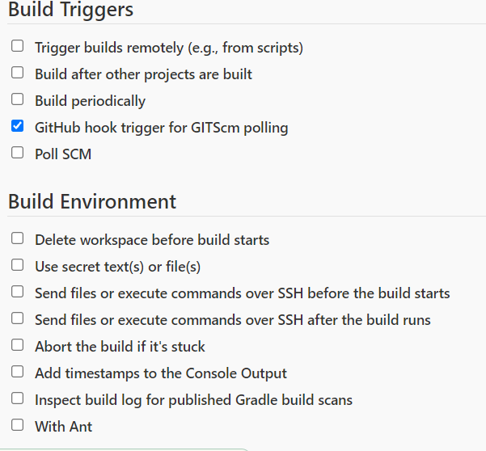

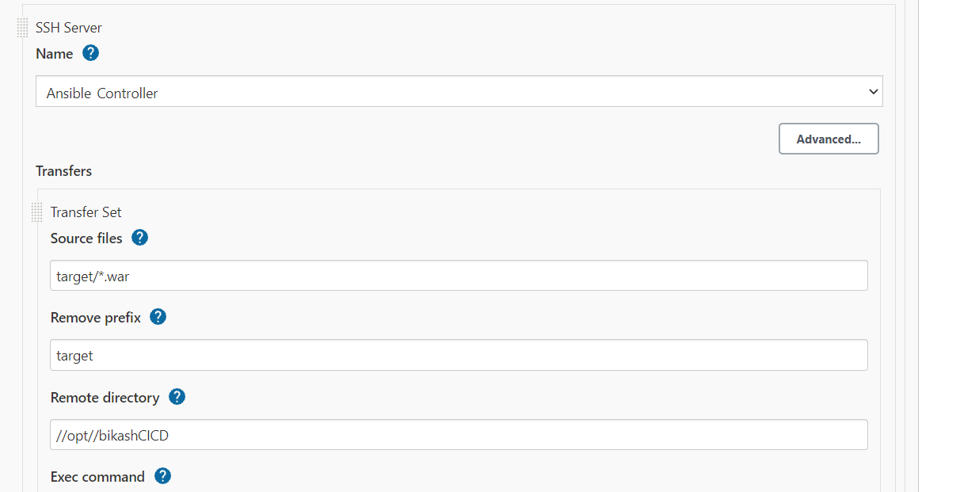

2> Project1_DockerImage

Using dockerplaybook.yml file placed in Ansible controller we are creating a Docker image using docker file and pushing it to Docker Hub

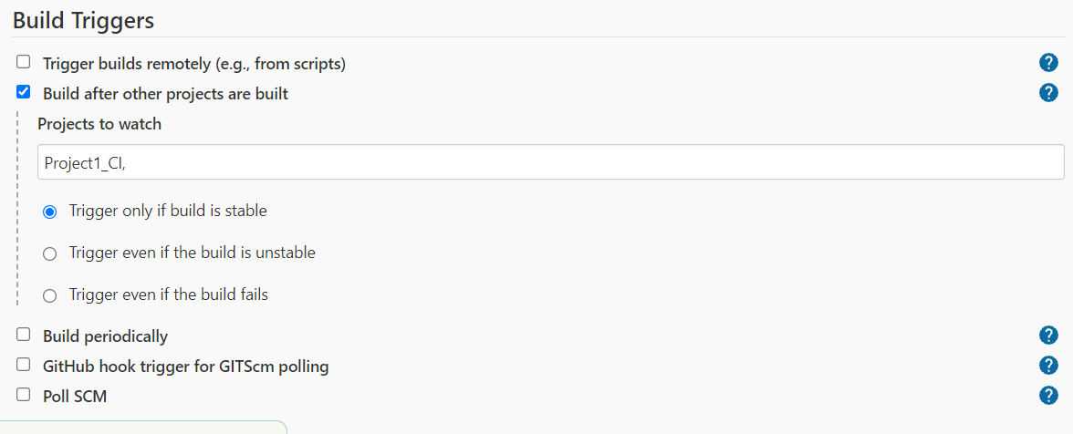

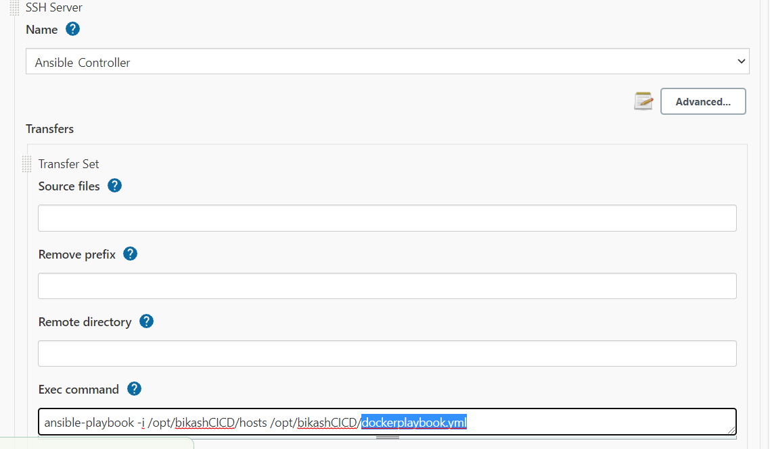

3>Project1_DockerDeployment

Using dockerswarmplaybook.yml placed in Ansible controller we are creating a docker service in QA server using the image build in the previous job

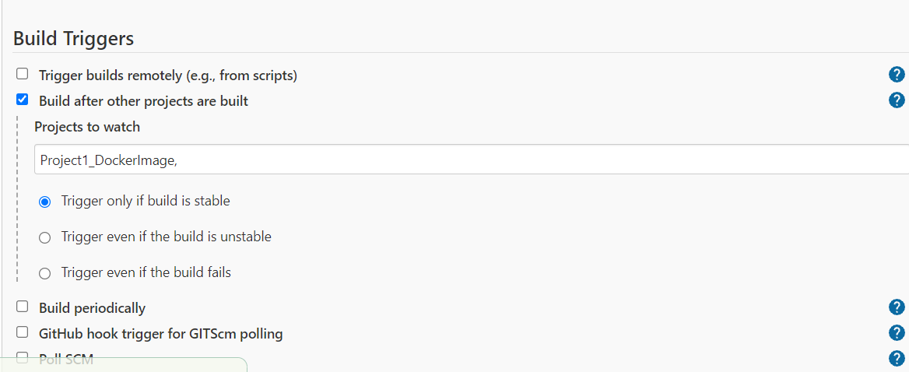

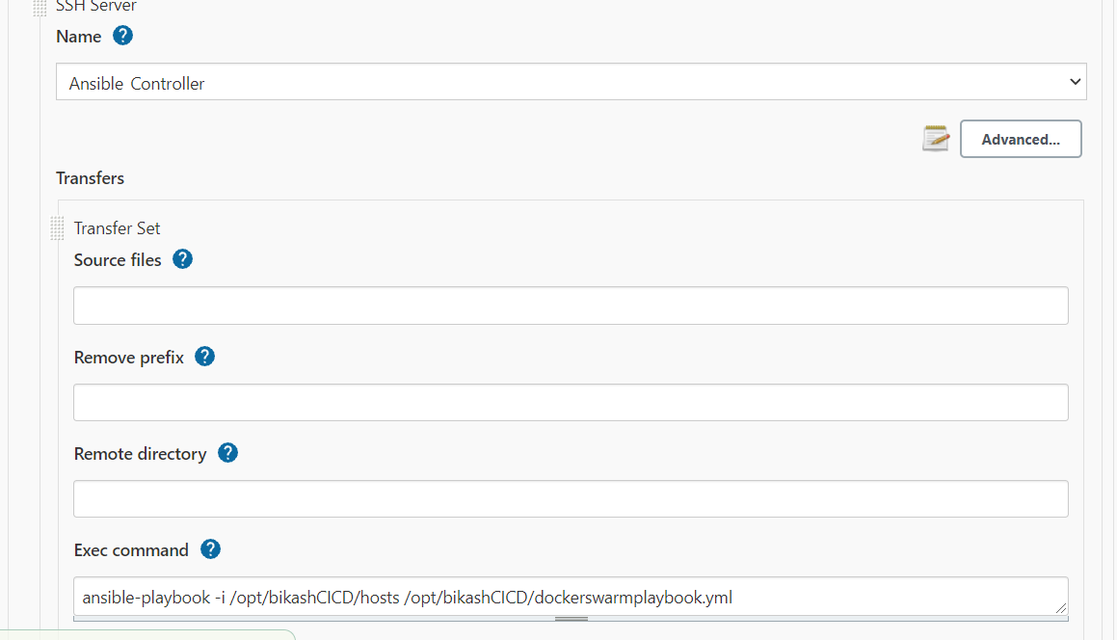

4> Project1_KuberneeteesDeployment

Using kubeplaybook.yml in Ansible controller we are creating Kuberneetees Cluster

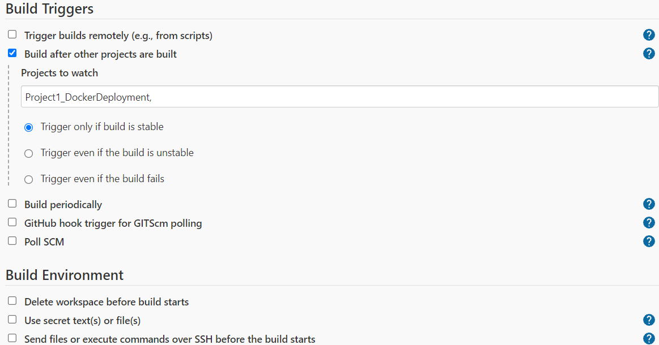

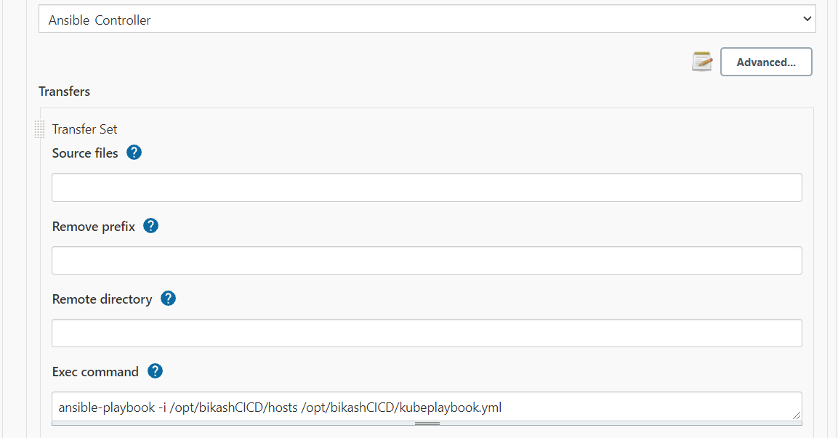

CICD Pipeline is built by Integrating all the four jobs

